Latte Panda GEM-2 Interface

# Introduction

A simple interface was created using a Latte Panda single board computer. It acts as a serial interface that can be connected to another device such as a MyRio which can send simple single characters to control a GEM-2 sensor. The GEM-2 is connected to latte panda via Bluetooth and the input serial port are connected with pins D0(Rx) and D1(Tx) on the latte panda board.

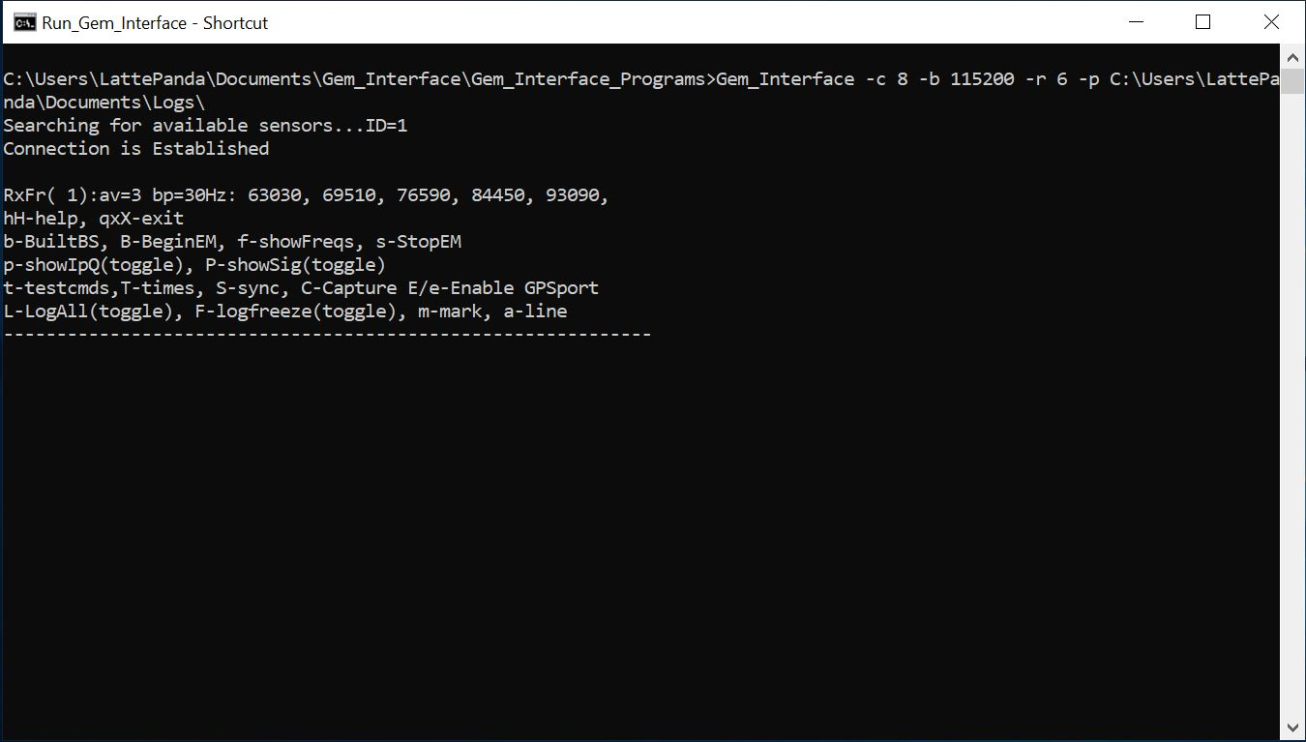

Figure : Gem Interface Program While Running

# Input Commands

The follow list contains commands and a short description that can be sent to the Latte Panda to control the GEM-2 sensor. Note- most commands are case sensitive.

H or h…………….. Help – Shows a list of commands in the Latte Panda command window

B or b…………….. Begin EM Transmission – Begins transmitting the EM wave form, This command should be run before starting a survey

f …………………. Show Frequencies – Shows the survey frequencies

L or l…………….. Begin Logging – Begins logging a survey, both EM and GPS ( if available ) will begin being recorded

p…………………. Poll for EM Data – Displays current EM Data in the Latte Panda command window, independent of logging

P…………………. Poll for GPS Data – Displays current GPS Data in the Latte Panda command window, independent of logging

F…………………. Pauses current logging – Toggles between logging being paused and not paused, also starts new line when logging goes from being frozen to recording

m………………… Set Marker

a…………………. New line or row

I or i……………... Status info – Prints status information to the Latte Panda command window

s…………………. Stop EM transmitter – Stops EM waveform transmission, this should be used at the end of a survey

G or g…………… Show latest GPGGA data – Prints the most recent GPGGA data to the Latte Panda command window

S………………… Sync times now – Requires incoming GPGGA GPS data

T…………………. Show current time – Prints current time to the Latte Panda command window

# Editing Configuration File

The configuration file can be edited to change were the EM and GPS data are saved as well as the COM ports for the serial communication and GEM sensor communication. The config file is call “Run_Gem_Interface.bat” and can be found in the location shown in figure 1.

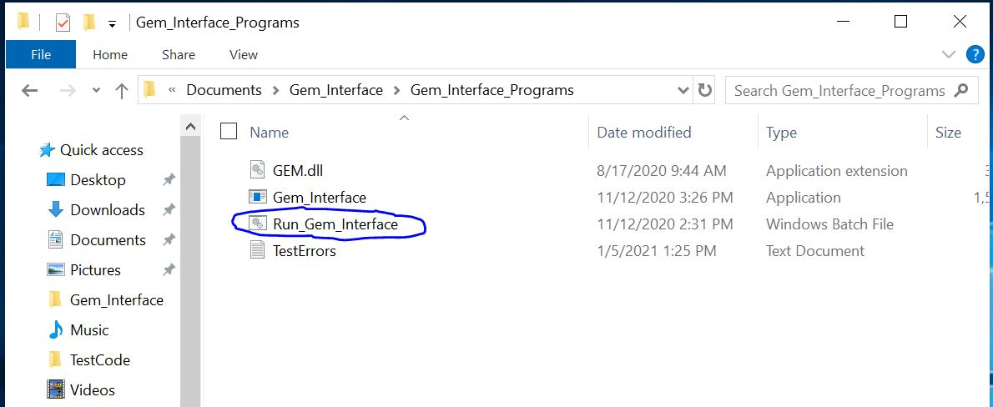

Figure 2

To edit the file right click on it and select edit. You with then be presented with a notepad document that can be edited. Three things can be edited in this file, the GEM COM port, the Serial Interface COM port and the location where files are saved. These will all needed to be set up on the setup of a new Latte Panda. In order for changes here to be made you must restart the Latte Panda or the Interface program.

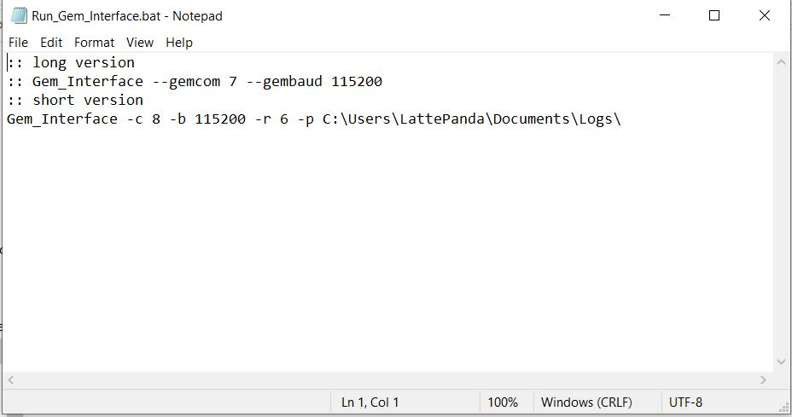

Serial Interface COM Number

GEM COM Number

Save Location

Figure 3

# Setting Up a New Interface

To setup a new Latte Panda the Interface programs must be copied to the documents folder, the Arduino program uploaded to the built in Leonardo, and then added to the start up folder. The start up program must also be modified to have to correct COM ports and a save files path.

First copy the Gem_Interface folder to the documents folder on the Latte Panda. Next open the Arduino IDE and open “Rio_Interface.ino”. Upload this program to the built in Arduino Leonardo. Then connect the GEM-2 sensor to the Latte Panda via Bluetooth. Next navigate to the Gem_Interface_Programs folder and edit the “Run_Gem_Interface.bat” file. You will need to edit the GEM COM port number, the Serial Interface COM port number and the saves location. To find the COM port number open the device manager on the Latte Panda. The Serial Interface COM port should be labeled “Arduino Leonardo”. The GEM COM port will be labeled “Standard Serial Over Bluetooth link”. If there is more then one, select one and try to run the “Run_Gem_Interface.bat” file. If the program closes out automatically try a different COM port. Next create a shortcut for the “Run_Gem_Interface.bat” file. Then press the windows key, type “run” and press enter. Next type “shell:startup” and press okay. In the folder that opens place the short cut for the “Run_Gem_Interface.bat” and restart the Latte Panda. Now on start up the Gem interface program should run.

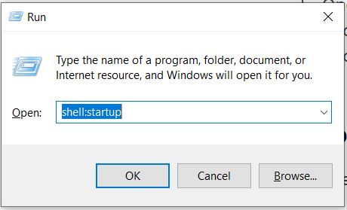

Figure